Sand Wizard of Catan
In which a dark and powerful force stands at the center of Catan, threatening to spread the desert until all is consumed.
(A disruption of Settlers of Catan for 3-4 players,)
by Alex Pantuck, Jack Collins, Simon Chen, Eduardo Barrera, Spring 2018

Basic Play: The game is similar to Settlers of Catan. There is one major change: the robber is now a powerful wizard, standing on the desert at the center of the board, and an when players roll a 7 instead of moving the robber they choose an adjacent hex to lose its number-disc, effectively spreading the desert. As the game progresses, the map tiles will change and the desert will slowly encompass the whole continent. Players must reach the winning victory points before the whole map becomes uninhabitable, and everyone loses.

Materials: Settlers of Catan game board and pieces

Objectives: Acquire either 5 (easy) or 8 (hard) victory points before the whole map turns into desert.

Rules:
Setup: Place the desert hex in the middle and randomly place all other island hexes around it, and water hexes around that. Randomly place all number discs on the non-desert hexes, and place the Sand Wizard (Robber) on the desert. Players then place their initial settlements and roads as normal.

Gameplay Changes: The robber is no longer moved to block resources and allow a player to steal cards; instead whenever a player rolls a 7, they take any two number discs and swap them. Additionally, if no one has to discard cards from having 8 or more cards in their hand, the desert spreads outward from the center, in whichever direction the player who rolled a 7 chooses: they turn over a number disc from one hex adjacent to the desert, or adjacent to the spread desert.
The Game:
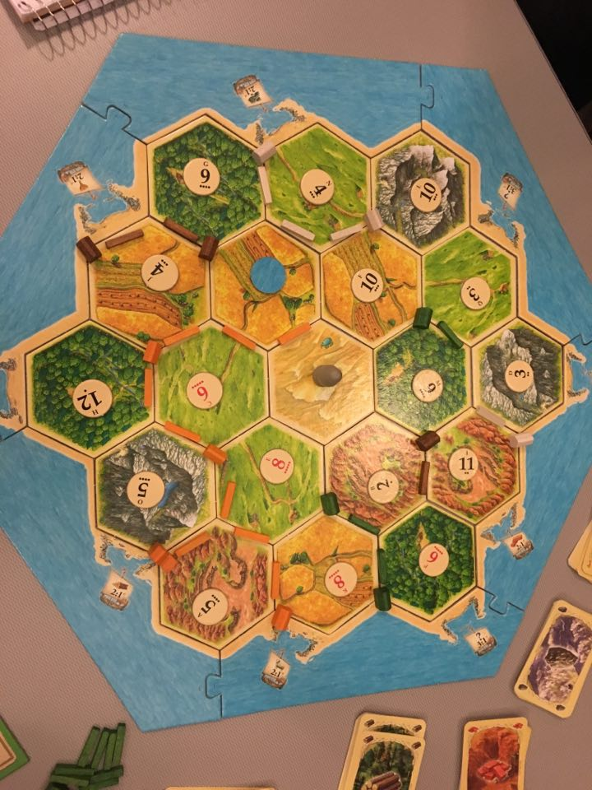
Setup:


