https://blog.kissmetrics.com/color-psychology/
How do colors affect purchases?

For retailers, shopping is the art of persuasion. Many factors influence how and what consumers buy, but a great deal is decided by visual cues, the strongest and most persuasive being color. Consumers place visual appearance and color above other factors such as sound, smell and texture. Consider these notes on Color Psychology:

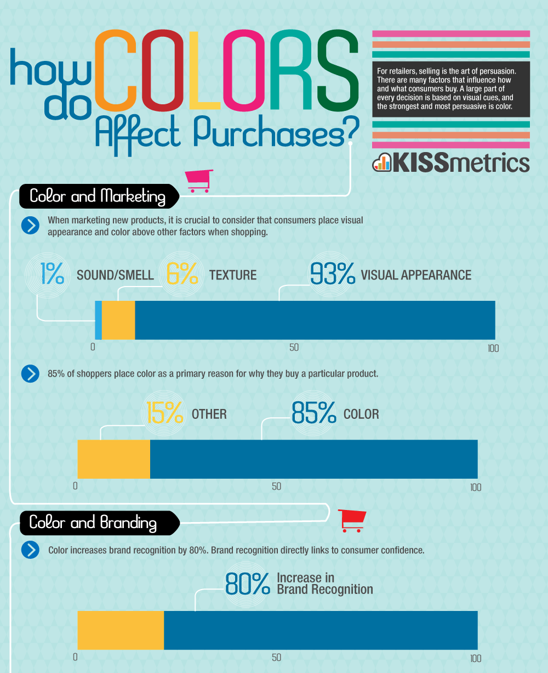
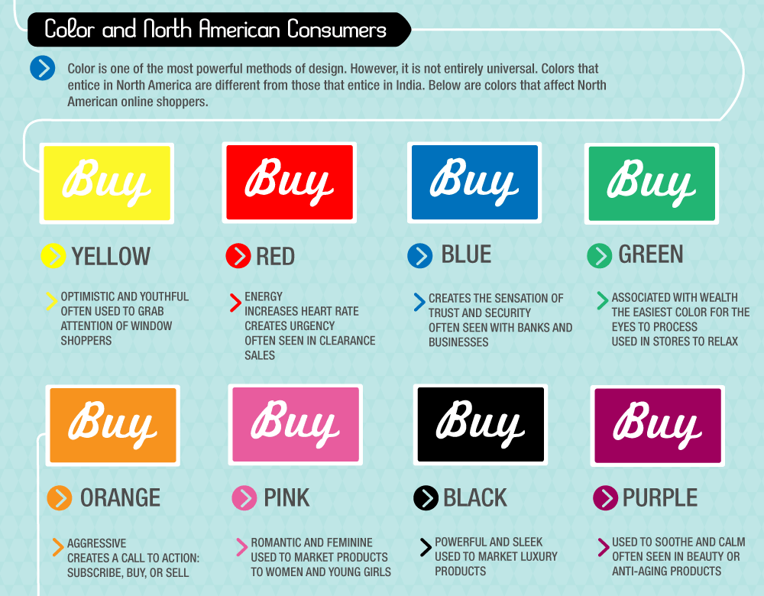

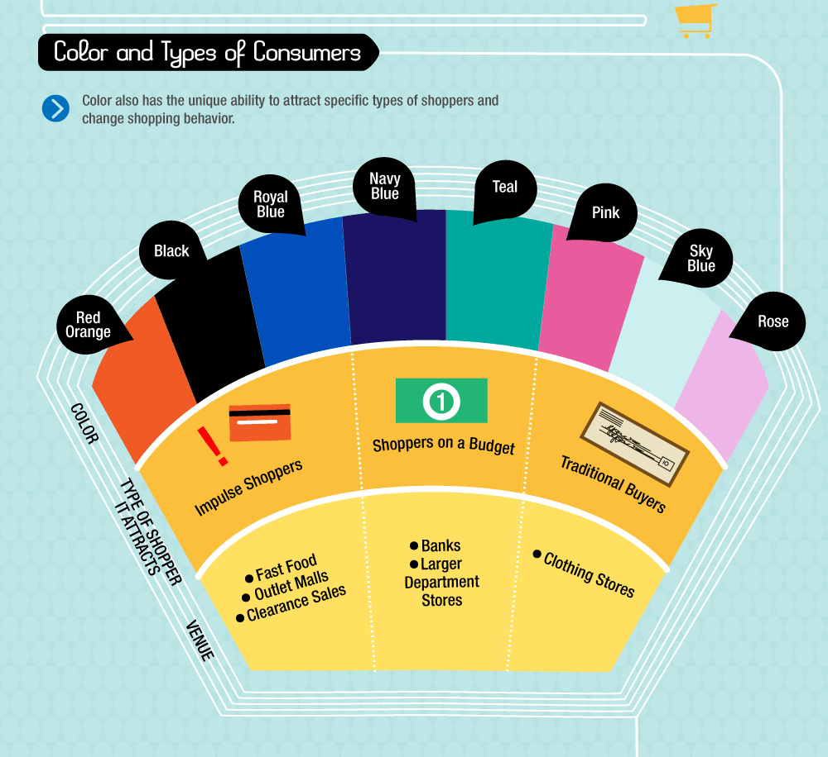

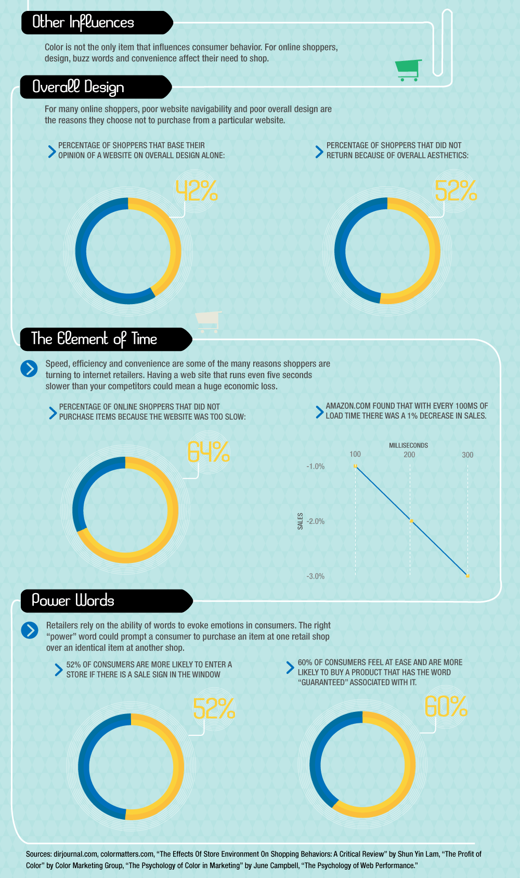

http://www.cnn.com/2013/03/21/living/real-simple-color-shopping/index.html
How Color Affects Spending

At the mall, nearly every shade of the rainbow can be found on signs, labels, doors, shopping bags. Those colors are strategically placed to influence spending. People subconsciously associate specific colors with specific social or cultural messages. Retailers select the colors to encourage spending.

Black: Signature color of sophistication, dominates high-end makeup packaging and can make inexpensive items seem more upscale.

Blue: Universally liked, it connotes trust and dependability. A favorite logo color for financial institutions seeking to make people feel secure, blue can improve customer loyalty: Patrons are 15 percent more likely to return to stores with blue color schemes than to those with orange color schemes (Journal of Business Research, 2003 study).

Burgundy and Brown: connote luxury (think red wine).

Green: Implies environmentally friendly.

Orange: Associated with fairness and affordability (used at stores offering value, like Home Depot and Payless).

Pink: Has calming effect ( particularly shades close to bubble gum, Journal of Orthomolecular Psychiatry study): seeing pink slows people's endocrine systems and tranquilizes tense muscles, relaxing and easing spending inhibitions.

Red: People typically react faster and more forcefully when they see the color red (red enhances physical reactions, is programmed into our psyche as a cue for danger). Grab a customer's attention and cue them to take action (purchase). (”Emotion” Journal study). Some market experts warn that, just like a stop sign, a red placard can make consumers hit the brakes. It serves as an alarm, triggering a more careful consideration of our outlays.

Violet: Associated with royalty, implies special properties and princely worth.

White: Suggests simplicity and purity. (75% of top skin-care brands are packaged in white.) Also stands for modernity and honesty (Apple swears by it).

Yellow: A mainstay at fast-food restaurants, evokes energy and increases appetite.

https://www.shopify.com/retail/119923395-why-all-sale-signs-are-red-the-science-of-color-in-retail
The Science of Color in Retail

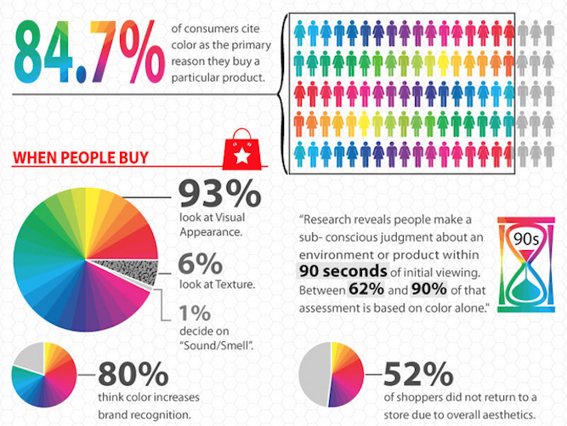

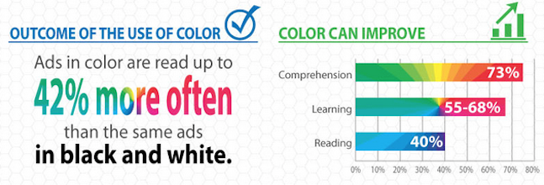

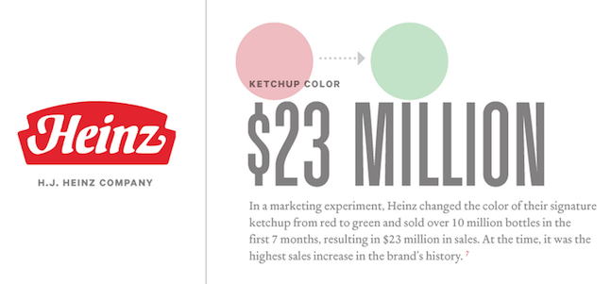

Severely and problematically oversimplified, but :
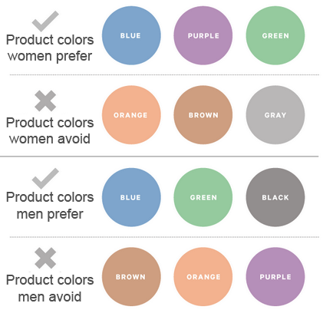

Choosing a Color Scheme
Consider one of these arrangements:
- Monochromatic Colors: varying tones of the same color.
- Complementary Colors: colors directly opposite each other on the wheel.
- Analogous Colors: colors lying on either side of a color on the wheel.
- Triadic Colors: Colors situated 120 degrees around the color wheel.
- Split-Complmentary Colors: A base color and two colors adjacent to its complementary color.
- Rectangular Colors: Four colors arranged into two complementary pairs.
- Square Colors: Four colors spaced evenly around the color wheel.



